| What is the **basic problem of economics**? | Scarcity is the basic problem of economics |
| --- | --- |

What are the **two assumptions** that economists make that make up the basic problem of economics?

| People have unlimited wants |
| --- |
| All resources are scarce/finite |

| What is an **opportunity cost**? | A opportunity cost is what you must give up that you usually do in order to benefit and gain something |
| --- | --- |
| What is an **opportunity benefit**? | An opportunity benefit is what you gain after using an opportunity cost. |

What do economists say are our **3 basic needs**?

| Food and Water |
| --- |
| Clothing |
| Shelter |

What are the **3 basic economic questions** that all communities must answer?

| What goods and services should be produced? |
| --- |
| How should these goods and services be produced? |
| Who should consume these goods and services? |

Who answers the basic economic questions in the following **types of economies**?

| **Command** | The government answers the basic economic question.Cuba and North Korea are examples |
| --- | --- |
| **Market** | Individual businesses and Individuals own resources(private ownership) and answer the 3 economic question |
| **Traditional** | Both the government and individual businesses answers 3 economic questions |

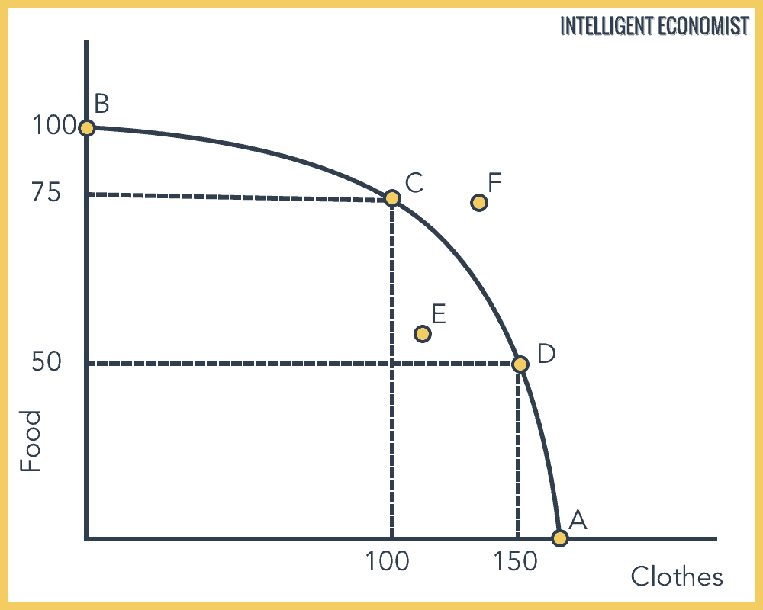

Using the **production possibilities** above, answer the following questions

| What is the **opportunity cost** of moving from Point C to Point D? | You lose 25 food and your demand for food decreases when moving from point c to d |
| --- | --- |
| What is the **opportunity benefit** of moving from Point C to Point D? | You gain a bunch of clothes when moving from point c to d |
| Understanding the **3 Regions of a PPF**: What can you say about a country producing at Point E? | On point e, a country isn’t producing efficiently |
| Understanding the **3 Regions of a PPF**: What can you say about a country producing at Point D? | On point d, a country is producing efficiently |
| Understanding the **3 Regions of a PPF**: What can you say about a country producing at Point F? | On point f, a country is producing something that can’t be attainable |

Demand

| Whose perspective do we focus on when we think about **demand**? | We look at the perspective of The consumer |
| --- | --- |

| What is the **law of demand**? | Inverse relationship between price and quantity demanded. Increase in price leads to decrease in quantity demand. Decrease in price leads to an increase in quantity demand |
| --- | --- |

| What causes a change in **quantity demand**? | When the price of something goes up the demand of of that good or service goes down |
| --- | --- |
| How would you show this on a graph? | A decrease in demand would shift the demand line to the left or right depending on how demand is used. |

| How would you describe what a **demand line/curve** looks like so that it follows the **law of demand**? | If there is an increase in demand then the demand line shifts to the right, if there is an decrease in demand, then the demand line shifts to the left. The demand line is a downward slope |
| --- | --- |

What happens to a **demand line/curve** when…

| demand increases? | You shift the demand line/ draw a new demand line to the right of the original demand line |
| --- | --- |
| demand decreases? | You shift the demand line/ draw a new demand line to the left of the original demand line |

| What is a **normal good**? | Generally an increase in income leads to an increase in demand . This is b/c consumers are more willing and able to buy more products.A increase in income leads to an increase in demand.A normal good is a good that experiences an increase in its demand due to a rise in consumers' income. |
| --- | --- |
| What is an **inferior good**? | Income and demand go in opposite directions.Generally an increase in income leads to an decrease in demand . This is b/c consumers are less willing and able to buy less products.A increase in income leads to a decrease in demand.an inferior good is a good whose demand decreases when consumer income rises |